WEEK-08-SORTING ALGORITHMS-BUBBLE AND SELECTION

WEEK 08-01-PRACTICE SESSION CODING REG NO : 240901086

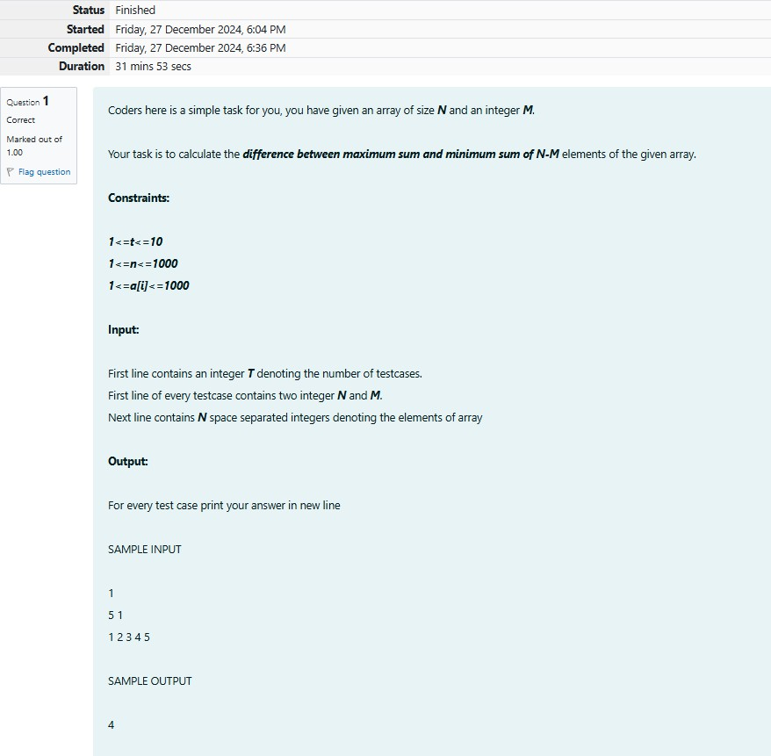NAME : RENUGADEVI S Q1)

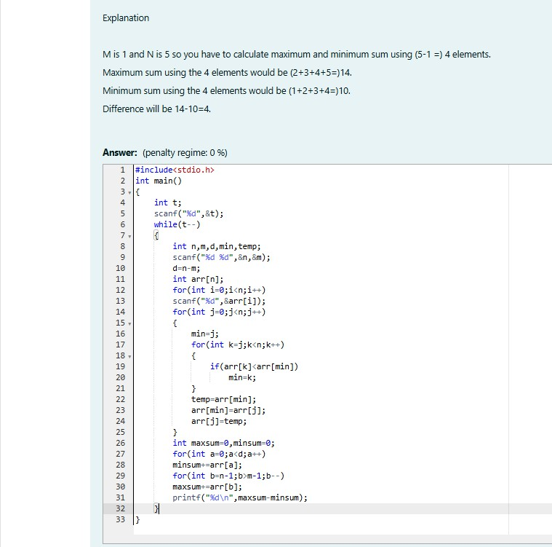

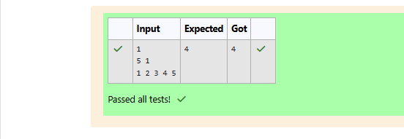

WEEK 08-01-PRACTICE SESSION CODING

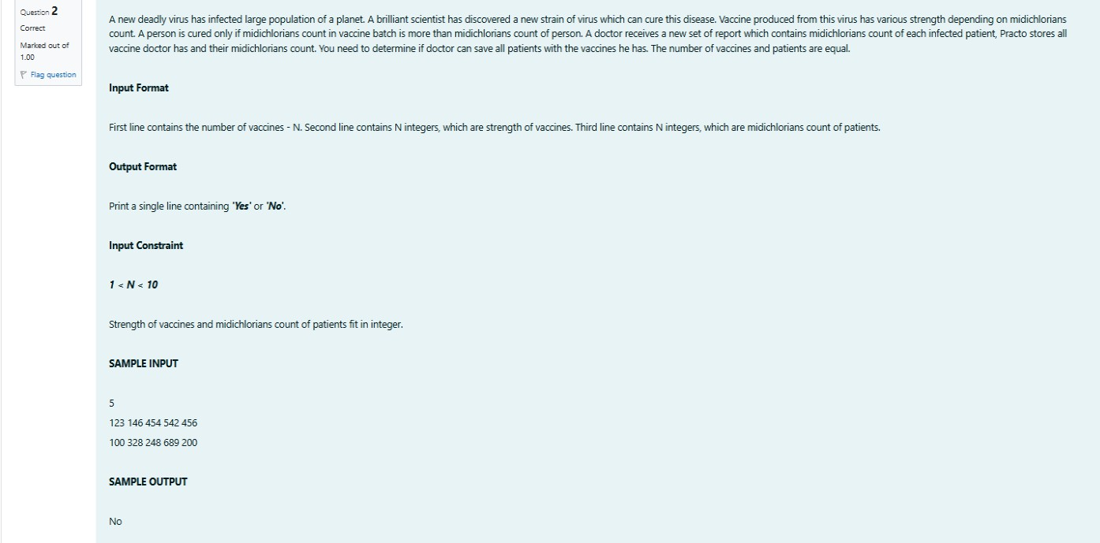REG NO : 240901086 NAME : RENUGADEVI S Q2)

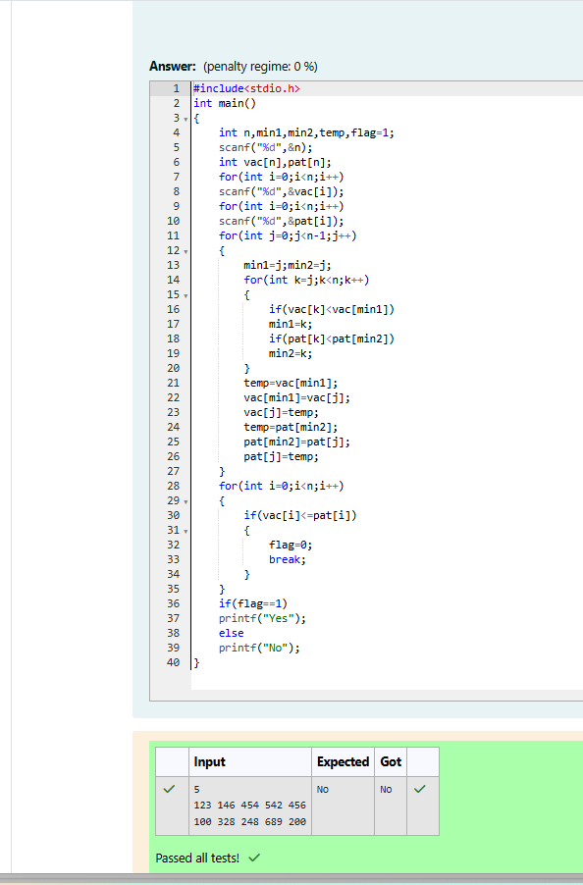

WEEK 08-01-PRACTICE SESSION CODING REG NO : 240901086

NAME : RENUGADEVI S Q3)

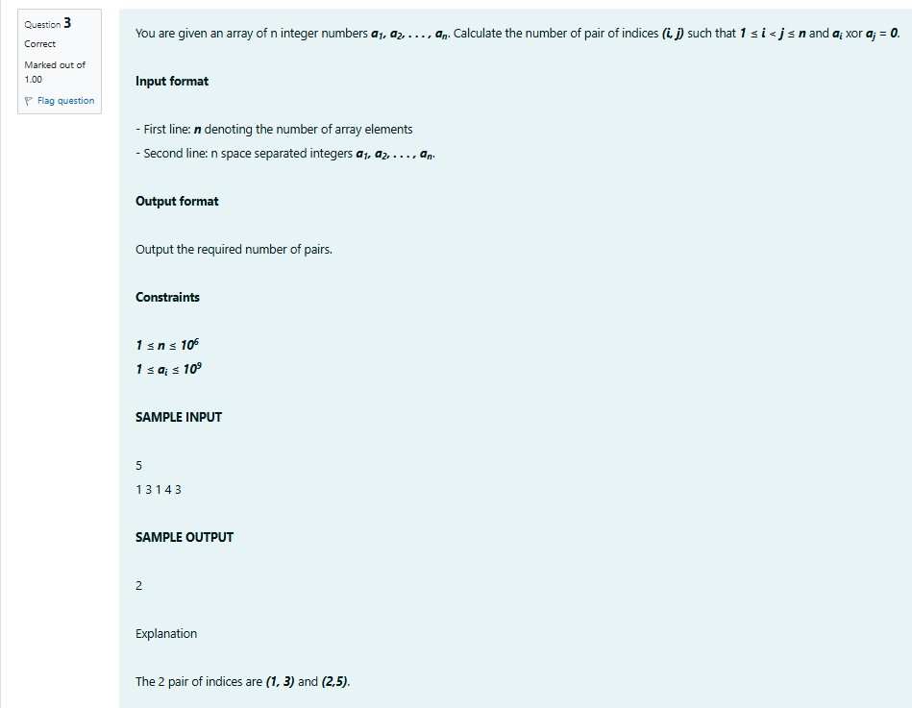

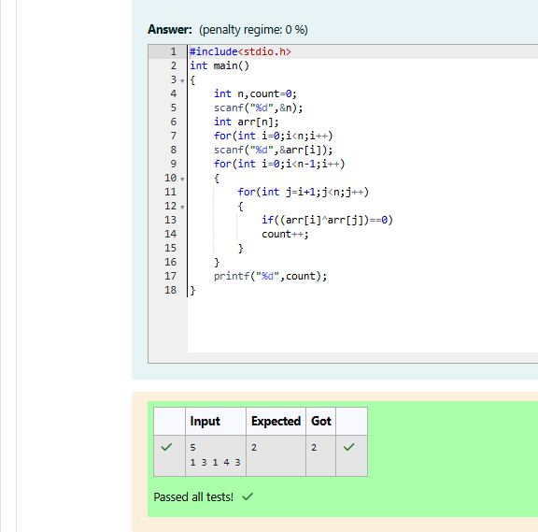

WEEK 08-01-PRACTICE SESSION CODING REG NO : 240901086

NAME : RENUGADEVI S Q4)

